**AWS Lambda**

* **AWS Lambda** is a service which computes the code without any server.
* It is said to be serverless compute. The code is executed based on the response of events in AWS services such as adding/removing files in S3 bucket, updating Amazon DynamoDB tables, HTTP request from Amazon API Gateway etc.
* You can write Lambda functions in your favorite language (Node.js, Python, Go, Java, and more) and use both serverless and container tools, such as AWS SAM or Docker CLI, to build, test, and deploy your functions.

**How Lambda fits into the event-driven paradigm**

Lambda is an on-demand compute service that runs custom code in response to events. Most AWS services generate events, and many can act as an event source for Lambda.

Unlike traditional servers, Lambda functions do not run constantly. When a function is triggered by an event.

An event triggering a Lambda function could be almost anything, from an HTTP request via [Amazon API Gateway](https://aws.amazon.com/api-gateway/), a schedule managed by an [Amazon EventBridge](https://aws.amazon.com/eventbridge/) rule, or an [Amazon S3](https://aws.amazon.com/s3/) notification. Even the simplest Lambda-based application uses at least one event.

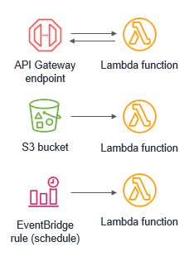

How AWS Lambda Works?

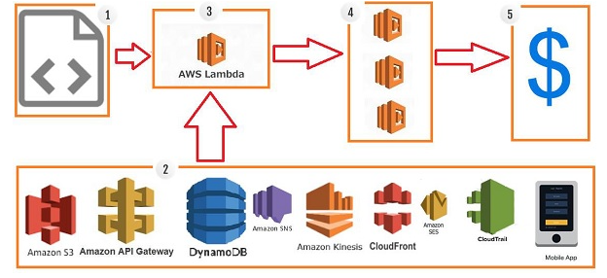

**Step 1 −** Upload AWS lambda code in any of languages AWS lambda supports, that is NodeJS, Java, Python, C# and Go.

**Step 2 −** These are few AWS services on which AWS lambda can be triggered.

**Step 3 −** AWS Lambda which has the upload code and the event details on which the trigger has occurred. For example, event from Amazon S3, Amazon API Gateway, Dynamo dB, Amazon SNS, Amazon Kinesis, CloudFront, Amazon SES, CloudTrail, mobile app etc.

**Step 4 −** Executes AWS Lambda Code only when triggered by AWS services under the scenarios such as −

* User uploads files in S3 bucket
* http get/post endpoint URL is hit
* data is added/updated/deleted in dynamo dB tables
* push notification
* data streams collection
* hosting of website
* email sending
* mobile app, etc.

**Step 5 −** Remember that AWS charges only when the AWS lambda code executes, and not otherwise.

## Advantages of using AWS Lambda

### Ease of working with code

### Log Provision

### Billing based on Usage

### Multi Language Support

### Ease of code authoring and deploying

Events that Trigger AWS Lambda

The events can trigger AWS Lambda are as follows −

* Entry into a S3 object
* Insertion, updation and deletion of data in Dynamo DB table
* Push notifications from SNS
* GET/POST calls to API Gateway
* Headers modification at viewer or origin request/response in CloudFront
* Log entries in AWS Kinesis data stream
* Log history in CloudTrail